Book Fair is coming back to Jackson
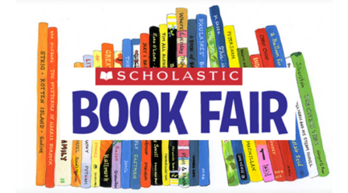

When: Monday 27th August – Friday 31st August
Time: 8.30am – 3.00pm
Where: Jackson Library
Why: Teachers want students to read, read, read and share their favourite books with their families and friends.
Who: All classes will visit the Book Fair to see what exciting books are available to buy this year.
What: Students will write a ‘Wish List’ to take home to share their ideas of books they would like to buy.
Parents can send the money to school in an envelope and students can buy their chosen books to take home.
OR
Parents, family and friends can visit the Book Fair
themselves and buy books to read or give as gifts.
Unable to buy? Put your wish list in a marked box at
school to give us your ideas of books to buy for our school Library.

NB: If any Parents have experience in helping to run a Book Fair and have time to spare the week of Monday 27th August please contact Bernadette O’Sullivan or Helen Puljak

