Dear Parents and Carers,
Numeracy and Literacy Week is upon us once more and we have a week of engaging activities for students to participate in.
Please look at the timetable to see when everything is happening.
Parents and Carers are welcome to attend:
Book Fair, Assemblies, PCFA Meeting and Classroom Showcase events (see timetable)

Competitions running during the week:
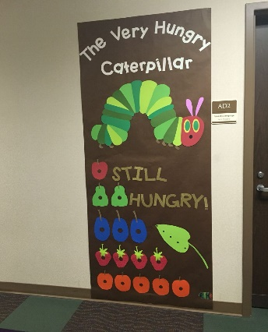
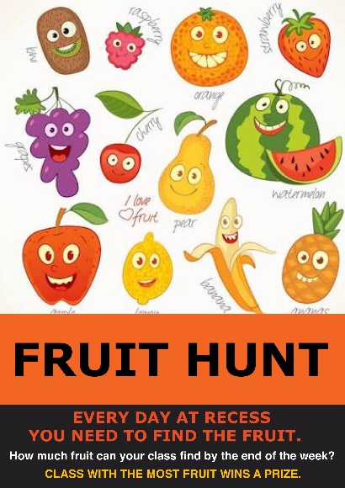
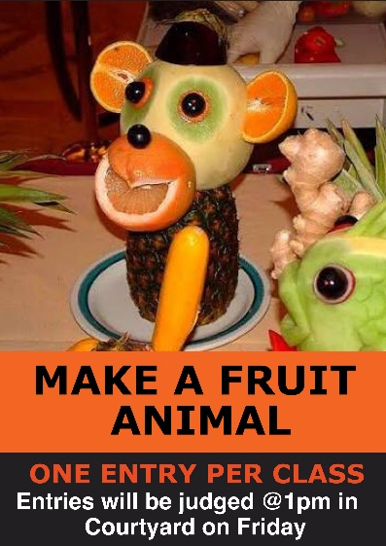
CLASSROOM DOOR
DECORATION

Raffle Tickets (To be handed to Office)
I would like ……………..tickets @ $1.00 each, or 6 for $5.00
Please find $....... attached.
Name of child for ticket …………………………………………….
Your ticket will be placed in the draw and the draw will be on Friday at the assembly. Prizes will be given then. Good luck!

