Monday 27  Students to wear tracky dacks to school today. | Tuesday 28  Numeracy Day | Wednesday 29  Literacy Day | Thursday 30  Classroom showcase from 11.30am – 1.15pm  (parents and carers invited) | Friday 31  Book character dress up day.
Book Fair Open (after recess)  9.20am  Whole School Kick off assembly  Competitions announced  Robyn Green to do readings with Primary between 11.30am and 1.00pm  Time Grade  11.40 – 12.00 46C and 46D  12.00 – 12.20 Prep and 34A  12.20 – 12.40 23A and 23B  12.40 – 1.00 46A and 46B | Book Fair Open  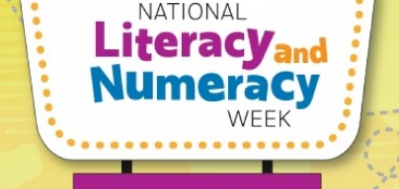  Numeracy  Rotations in Departments | Book Fair Open  Literacy  Rotations in Departments  Guest Readers in the Library during the middle block. | Book Fair Open  Classroom Showcase  Parents and carers are invited to visit their child’s classroom between 11.30 and 1.15pm to see the great work they have been doing.  1.30pm  PCFA Meeting in the staff room. All welcome | Book Fair Open  (closing at recess)  9.00am – 12.00pm  Father’s Day stall  PCFA Group running it.  2pm  Whole School Assembly  Results of Competitions

