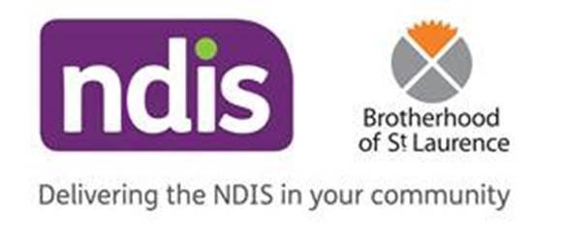

NDIS PARENT DROP IN SESSIONS
@ Jackson School

To further support our parent/carer community with the NDIS, we have a drop-in sessions running on the first Thursday of each month (excluding school holidays). Parent/carers can drop in at any time to chat with the team from Brotherhood St Lawrence, Sunshine. Any questions, NDIS plan queries etc can be answered by the team onsite at Jackson School. No bookings required!

Sessions run on the first Thursday of each on the excluding school holiday. Dates as follows:
6th February – 8:30am-1:00pm
5th March – 8:30am-1:00pm
7th May – 8:30am-1:00pm
6th August – 8:30am-1:00pm
3rd September – 8:30am-1:00pm
1at October – 8:30am-1:00pm
5th November – 8:30am-1:00pm
3rd December – 8:30am-1:00pm

